[](https://www.superyachtsmonaco.com/sales/negara) **SUNSEEKER 131’**

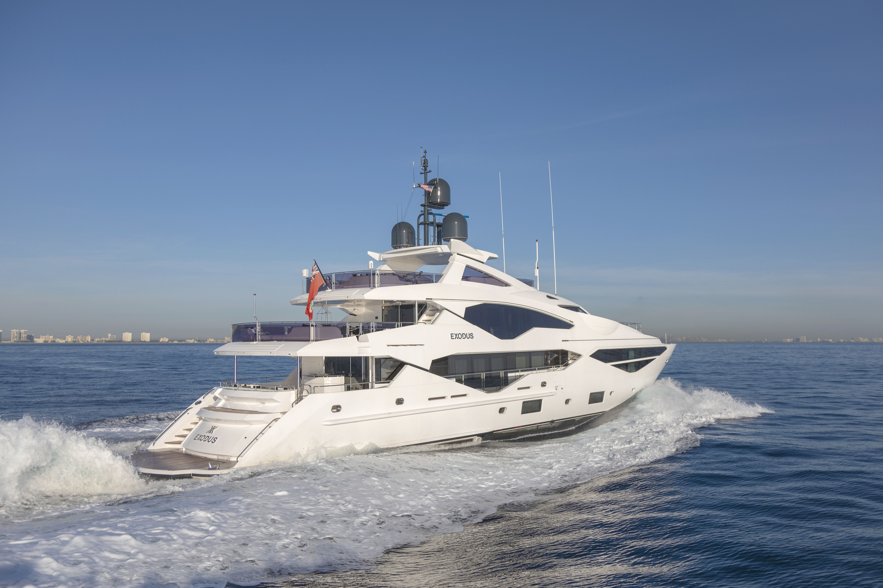

**LO**.**A**: 40.05 m

**Beam**: 8.09 m

**Max** **Draft**: 2.85 m

**Hull**: Fiberglass

**BUILT:** 2019

**ACCOM:** Guests 12 in 5

Crew 8

**CLASS**: RINA  
**Ext.** **DESIGN**: SUNSEEKER INT.

**Int. Design:** SUNSEEKER / OWNER

**ENGINE**: 2 x 3,181 hp MTU

DIESEL ENGINES

**SPEED**: Cruising 16 knots

**LYING:** [WEST](https://www.marinetraffic.com/en/ais/details/ships/shipid:5716728/mmsi:319160400/vessel:EXODUS) MED

**COMMENTS**

* Under shipyard warranty
* Extended MTU EPC 3 year warranty
* Built under supervision of owner’s independent technical team / surveyor
* Highly specified and customized high-quality interior (Dornbracht, Yacht Intelligence A/V etc.)
* Built to MCA LY3 Unrestricted navigation & Commercially operated
* Extra sound insulation all around Master Cabin to reduce noise from all angles
* Shore power converter for worldwide operation
* Trailing pumps fitted for slow speed cruising allowing for very low fuel consumption
* Thermal tracking camera for chase boat operation
* GBP 2,985,000 of extra options not including extra A/V and custom interior additions
* Preventative maintenance ongoing with full time crew aboard

Launched in March 2019 EXODUS and most highly specified Sunseeker 131 on the market with an extremely competitive asking price.

**SPECIFICATION**

TYPE Twin Screw, Semi-Displacement hull, Motor Yacht

FLAG Bloody Bay, Cayman Islands [KY]

CLASSIFICATION Rina and LY3: C + Hull. Mach Ych (MCA) Unrestricted navigation EFP DMS (Enhanced fire protection and damage stability).

BOAT NUMBER 61519131 /15th Hull delivered in the 131 series

DIMENSIONS Length O.A. 40.05 m (131’5”)  
Length Registered 32.82 m (107.6”)  
Beam 8.09 m (26’7”)  
Draft 2.70 m (8’10”)  
Height (W.L to arch) 9.20 m (30’2”)

VOLUMES GRT 343  
NET TON 102

DISPLACEMENT 189,600 kg

YEAR BUILT March 2019

BUILDER Sunseeker International, Poole, Uk

HULL DESIGNER Sunseeker International, Poole, Uk

INTERIOR DESIGNER Sunseeker International, Poole, Uk / Owner

CONSTRUCTION Hull: Glass Reinforced Plastic

Superstructure: Glass Reinforced Plastic

Deck: Teak laid on Glass Reinforced Plastic

**MAIN MACHINERY**

MAIN ENGINES 2 x 3,181 hp 12 cylinder 12V4000M93L Diesel Engines  
Under MTU EPC extended warranty 3 years or 3,000 hrs

ENGINE HOURS 14/12/2020  
Port: 907 hrs

Starboard: 907 hrs

GEARBOX 2 x ZF 7600 A, ratio 3.286:1

SHAFTS & PROPELLERS 2 x Duplex F51 high grade stainless steel  
2 x 5-blade NAB bronze propellers

SPEED & CONSUMPTION (approx.) Max 21 knots @ 2,100 rpm  
Cruising 12 knots @ 1,250 rpm = 300 lt/hr Cruising range 12 knots for approx.. 1,116 nm  
Fuel curve available on request

AU**XILIARY MACHINERY / EQUIPMENT & ELECTRICAL SYSTEM**

GENERATORS 2 x Kohler 80Kw 400/230V 3 Phase 50HZ – 80EFOZDJ with sound shields. Upgraded from standard. 2 x PTO

GENERATOR HOURS 14/12/2020  
Port: 2,544 hrs  
Starboard: 2,329 hrs

SHORE POWER 1 x 125A flexible 20m cable in electric reeling system  
1 x 125A loose flexible 20m cable connected to Atlas 90 kVA-SPA-II Series 50Hz. Input 180-530V single or three phase up to 90kVA

THRUSTER Bow Thruster: ABT TRAC 100HP (513mm)  
Stern Thruster: ABT TRAC 65HP (412mm)

STABILISATION ABT TRAC 440 digital fin stabilizers

SEWAGE TREATMENT ECOmar 32 (3,200 l/day) 230V 1 Phase 50Hz

WATER MAKERS 1 x Idromar 375 litres per hour (upgrade)  
1 x Idromar 375 litres per hour (additional)  
+ Octo marine water softener

FUEL SEPARATOR Alfa Laval MIB303 fuel cleaning centrifugal separator 240V 1 Phase 50 Hz 760 L/hr

WC’S Tecma Silence Plus 220 Volt AC macerating toilets

AIR CONDITIONING Marine Air MCG V120 chilled water system to Tropical specification (4 x 120000 BTU) with quieter WhisperCool DC fans   
2 x Marine Air 54,000 BTU self-contained units in the engine room**CAPACITIES (approximate)**

FUEL 19,000 litres / 5,019 US gallons main tank  
3,900 litres / 1,030 US gallons day tank  
5,700 litres / 1,505 US gallons additional tank upgrade

TOTAL FUEL 28,600 litres / 7,555US gallons

WATER 4,950 litres / 1,307 US gallons

GREY WATER 1,350 litres / 356 US gallons

BLACK WATER 1,450 litres / 383 US gallons

**NAVIGATION & COMMUNICATION EQUIPMENT (LY3 compliant)**

VHF Sailor 6222  
Sailor 6204  
Simrad RS90 Class D VHF/DSc with Handsets in Wheelhouse, Crew Mess and Emergency Steering Position

CHART Transas Navi-Sailor 4000 ECDIS  
Upgrade Transas AIS, ARPA and radar integration

RADAR Furuno FAR2837S-BB S-Band 3GHz with 10’ Open Scanner with Furuno processor RPU

MEASURING LOG Sperry Naviknot 350E with FNFII through hull sensor

ECHO SOUNDER Furuno FE800 Echo sounder 200 khz with 200B-8B transducer  
Wasp forward facing 3D mapping

GPS Furuno GP170 GPS Navigator with GPS antenna

AIS Furuno FA170 Class A transponder with GPS and VHF antenna

WATCH ALARM Furuno BR500

RUDDER ANGLE INDICATOR Simrad RF45X

GYRO COMPASS Satellite Hemishpere GNSS V103

AUTOPILOT Simrad AP70

RADIO MF: Sailor 6310 MF/HF 150W Radio telephone

INMERSAT C. Sailor 6110

NAVTEX Furuno NX700B

EPIRB McMurdo E5

SART McMurdoS4

THERMAL CAMERA Flir M400XR Stabilized Thermal and Daylight Camera with tracking facility. Installed on navigation mast to allow monitoring and tracking of chase boat.

**AUDIO / VISUAL ENTERTAINMENT SYSTEMS**

FULL LIST OF ULTRA HIGH-END EQUIPMENT FITTED THROUGHOUT ON REQUEST

CONTROL SYSTEM Crestron automation throughout

**DOMESTIC EQUIPMENT**

MAIN GALLEY 4 x Frigoboat 1,440 lt each

2 x Frigoboat 646 litres freezer capacity each  
2 x Miele H6460BP single convection ovens  
Miele KM6879 Induction hob 5 zone – 900mm  
Extraction fan – Systemair KE 50-25-4230V 1 Phase 50Hz with Actionair AirShield.  
Icemaker 22kg / day  
Miele ESW229X 29cm plate warming drawer   
Slimline 190 litre trash compactor   
132 bottle Wine Cooler  
Bridge deck wine cooler Miele

STERN LAUNDRY Miele 2 x washing machine, 2 x tumble dryer and dishwasher

**TENDERS & WATERSPORTS EQUIPMENT**

TENDERS 1 x Williams 565 Diesel Jet tender (serviced 12/2020).   
Fuelling station in garage.

WAVERUNNERS 2 x Sea-Doo RXP-X 300 with Venom Custom Tuning Package - Wave Runner Trackers fitted linked to the vessels bridge navigation systems  
(serviced 12/2020)

TOYS 2 x Sea Bob F5 SR

**DECK EQUIPMENT**

ANCHOR WINDLASS Lewmar V10 hydraulic powered Windlass.

ANCHORS 2 x Manson Kedge 210kg galvanised bow anchors  
Connected to 19mm x 165m high tensile galvanized studlink chain. Upgraded from standard.

AFT WARPING CAPSTANS 2 x Lewmar C10 Hydraulic

PASSERELLE Besenzoni Hydraulic upgraded heavy duty three stage Telescopic stainless steel Passerella 6.1m

BOAT CRANE & DAVITS Jet Ski overhead crane and chock system

SWIMMING PLATFORM Hydraulically fall rise and tilt platform with maximum lift capacity of 2000 kg

UNDERWATER LIGHTS 21 x White and Blue Lumishore LED

COMPRESSED AIR SYSTEM Portable air compressor stored in engine room with AC 220V power supply.

DIVE COMPRESSOR 300 bar pressure Dive / Ba compressor

**SECURITY & SAFETY EQUIPEMENT**

RINA COMMERCIAL LY3 COMPLIANT

**ACCOMODATION**

GUESTS 1 x Master on main deck with king size bed, ensuite bathroom with underfloor heating and wardrobe.   
2 x Midship lower deck VIP cabins with queen size beds and ensuite with underfloor heating.  
2 x Twin cabins with sliding convertible single beds, pullman and ensuite with underfloor heating.

CREW 3 x bunk cabins with ensuite bathroom  
1 x single cabin with ensuite bathroom

**MAINTENANCE**  
  
2020

November 1,000 hrs Main Engine service performed by MTU   
Generators serviced by Kohler

May Topsides polished

**EXCLUSIONS**

Name reserved and excluded from the sale. An exclusion list will be provided to all interested parties, which mainly consists of Owner’s personal effects.

**GENERAL ARRANGMENT**

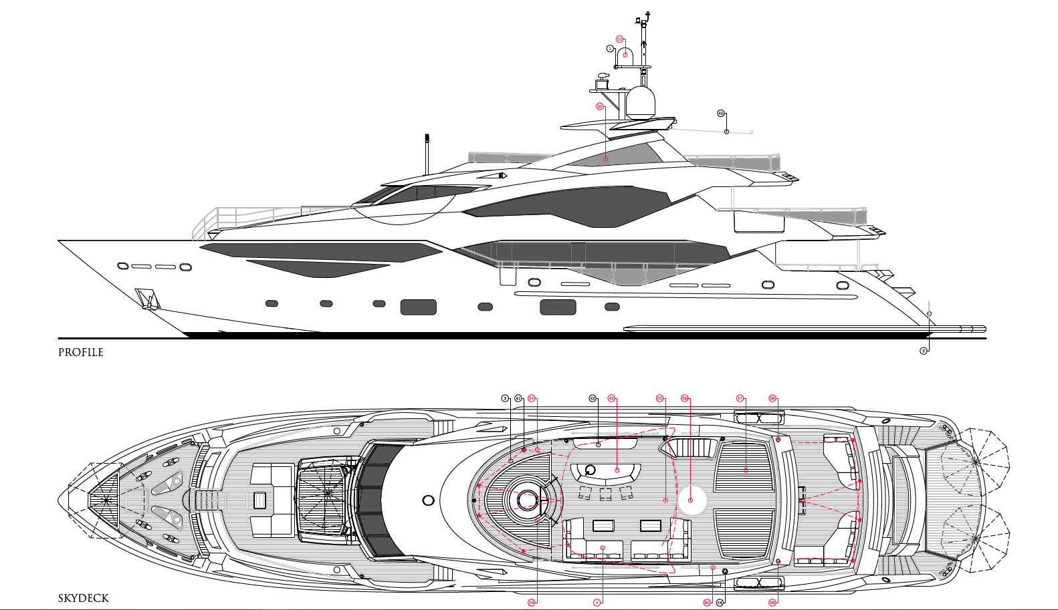

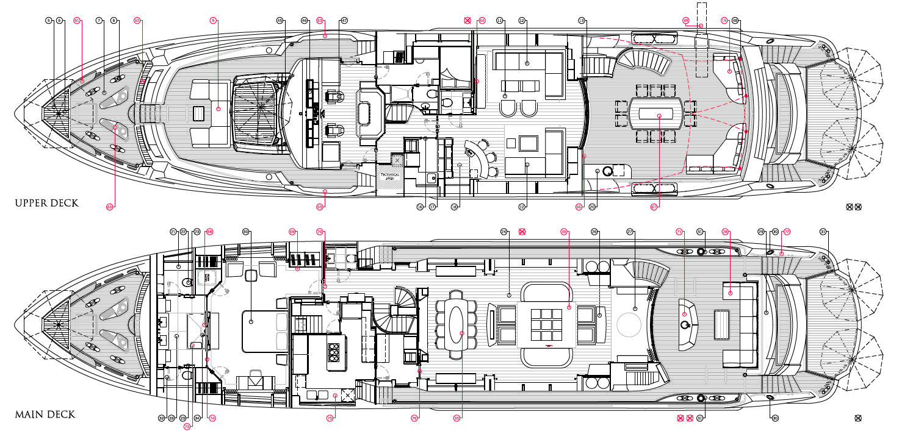

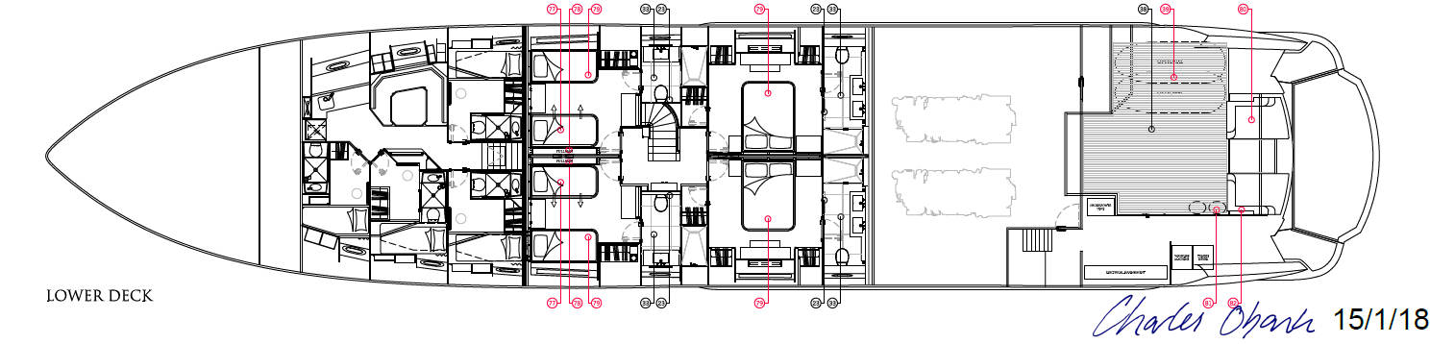

These particulars have been prepared from information provided by the sellers and are intended as a

general guide to the vessel. We cannot however, be liable for any inaccuracy. It is up to the purchaser to confirm details of concern to him by survey inspection and/or enquiry of the seller and to ensure that the purchase contract properly reflects his concern and specific details upon which he may relay. We always advise an independent survey.